Task 1 – Building a Recommender System
Objective
The goal of Task 1 is to create a User–Book recommender dataset from the provided Ratings.csv file.
Each row represents a user, each column represents a book, and the matrix entries correspond to the user’s rating for that book.
This dataset will be used to build and evaluate recommendation algorithms that learn user preferences.

Data Preparation Steps
Step 1 – Loading the Dataset
The original file Ratings.csv was loaded using pandas with the appropriate separator (; or tab).
The dataset contained three columns:
- User-ID – unique identifier for each user
- ISBN – unique identifier for each book
- Rating – integer rating assigned by the user

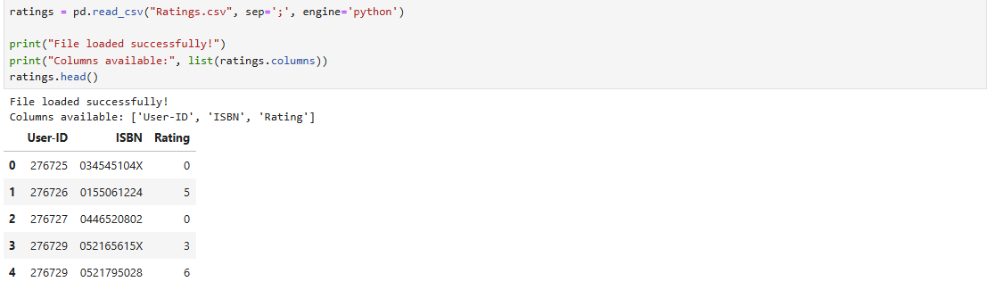

Step 2 – Data Cleaning
- Converted ratings to numeric values.
- Dropped missing or invalid entries.
- Removed duplicate user–book pairs, keeping only the most recent rating.
- Verified data shape after cleaning.
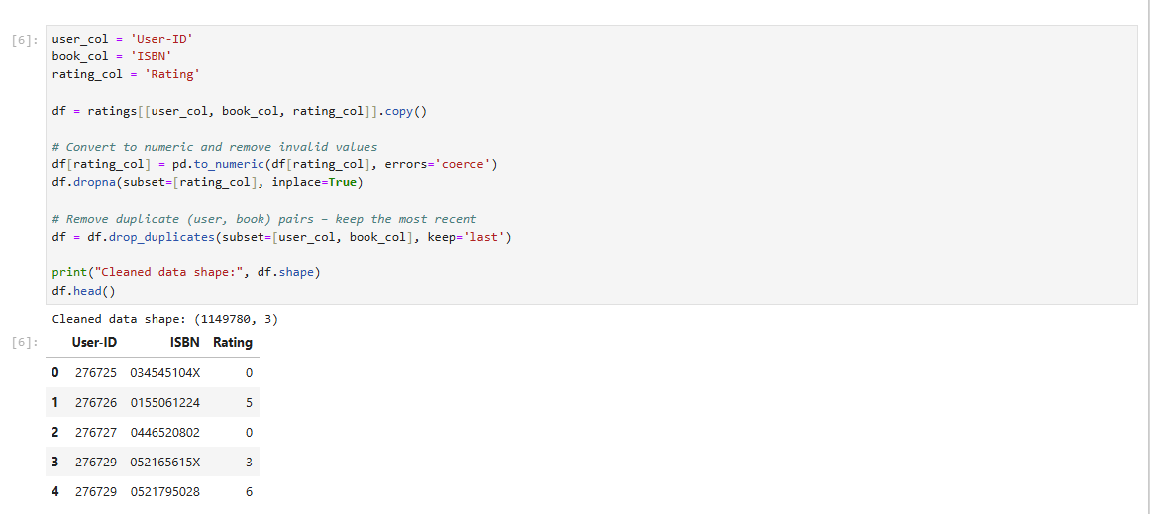

Step 3 – Encoding Users and Books
Since recommender systems require numeric indices, each user and each book were encoded into integer IDs using pandas category.codes.
This yielded:
- 105,283 unique users
- 340,556 unique books
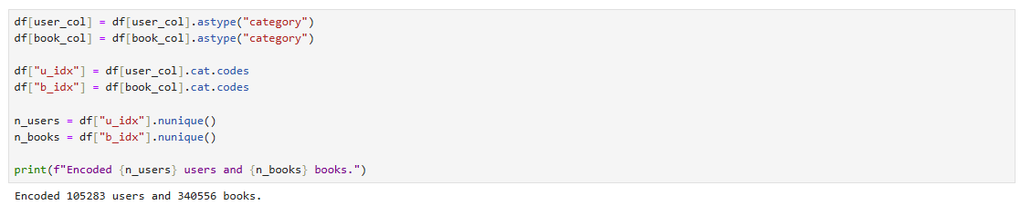

Step 4 – Building the Sparse Matrix
Using SciPy’s coo_matrix, a large sparse matrix of shape (105,283 × 340,556) was constructed, where most entries are zeros (no rating).
This format is memory-efficient and ideal for recommender algorithms.
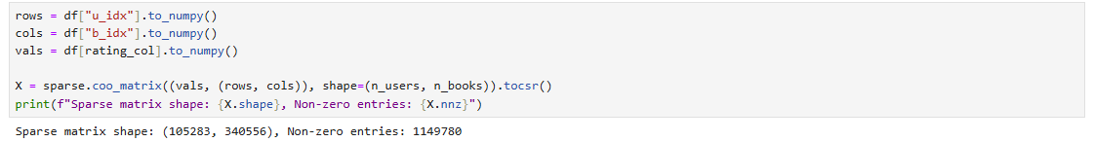

Step 5 – Exporting to LIBSVM Format
The matrix was exported to dataset.libsvm using scikit-learn’s dump_svmlight_file.
Because Task 1 is unsupervised, there is no dependent variable (y).
Therefore, an all-zero y-vector was included only to meet LIBSVM format requirements.
Example lines from dataset.libsvm:
0 32069:0
0 231:5 10495:0 72058:0 84148:0 90587:0 95565:0 ...
Here:
- 0 = dummy y-value (unused)
- 231:5 = book #231 rated 5 by this user
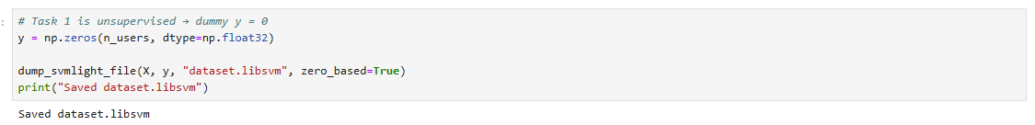

Step 6 – Saving Index Maps & Statistics
Three supporting files were generated:
- user_index.csv – maps User-ID → row_index
- book_index.csv – maps ISBN → column_index
- matrix_stats.json – stores dataset statistics
Example contents of matrix_stats.json
matrix_stats
:
{
"n_users": 105283,
"n_books": 340556,
"nnz": 1149780,
"density": 3.2e-05
}
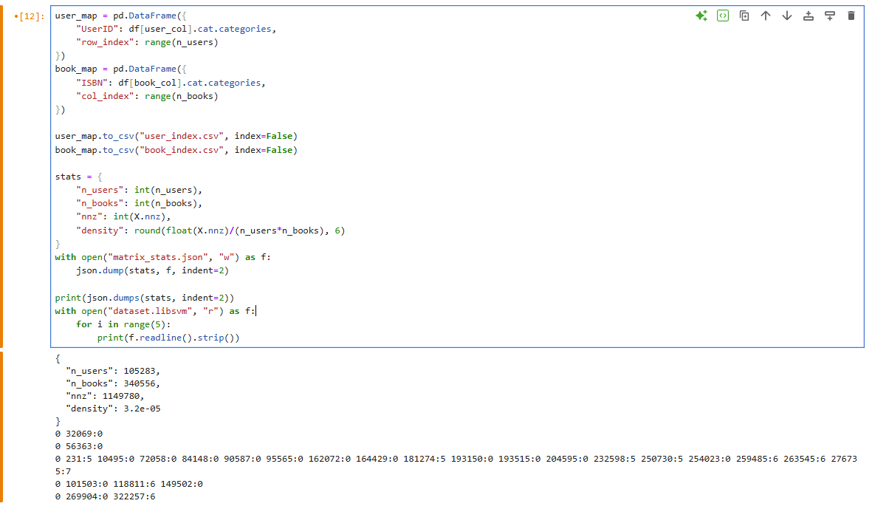

Explanation of Output Files
File Name | Description
dataset.libsvm | Final sparse matrix of all users and books, ready for recommender algorithms.
user_index.csv | Lookup table mapping each user’s original ID to its matrix row index.
book_index.csv | Lookup table mapping each book’s ISBN to its column index.
matrix_stats.json | Summary statistics about the dataset (size, density, number of non-zero ratings).

Interpretation of Results
- Matrix Shape: (105,283 users × 340,556 books)
- Non-zero ratings: 1,149,780
- Density: 0.0032 % (typical for real-world recommender data; most users rate only a few books)
This confirms that the dataset was prepared successfully and is ready for collaborative-filtering or matrix-factorization models.

Important Note on the y Vector
LIBSVM format requires a target y value for every row.
Because this task is unsupervised, we used an all-zero y-vector only to meet the format requirement.
The y-values are not used in any analysis or recommendation computation.

Verification
After saving, the dataset was re-loaded using load_svmlight_file:
Reloaded shape: (105283, 340556) | Sample y: [0. 0. 0. 0. 0.]
This confirms that the file is correctly formatted and can be used directly for recommender-system modeling.

Conclusion
The data preparation for Task 1 – Recommender System was completed successfully.
The generated LIBSVM dataset and supporting files meet all project requirements and are suitable for building user–book recommendation models using collaborative filtering, similarity-based, or matrix-factorization techniques.

